**Unit Test Report**

# Database

## Creation of table

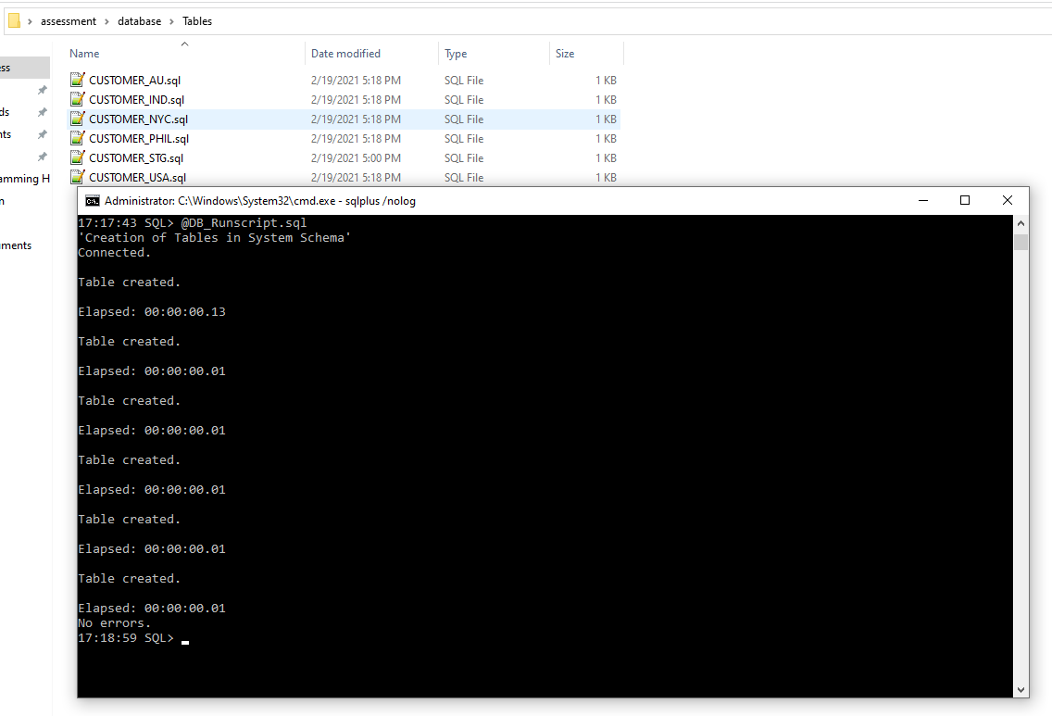

Figure : Creation of Tables using Runscript

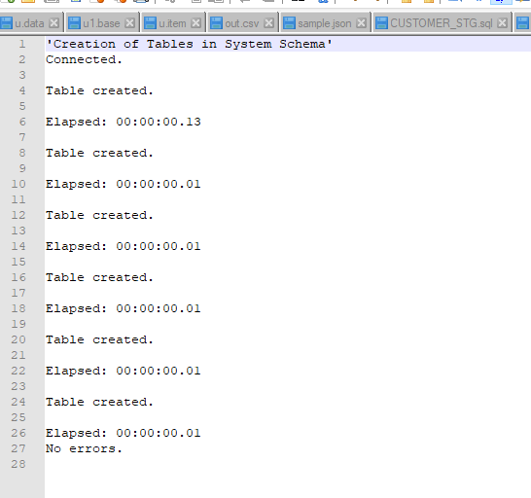

Figure : Runscript log

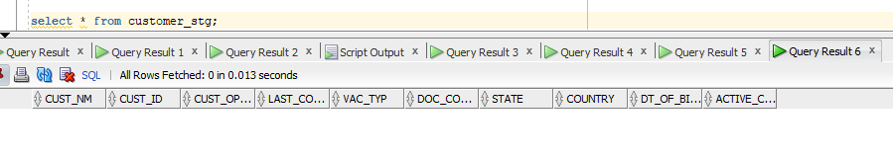

Figure : Staging table



## Python – Extract, Transform and Load

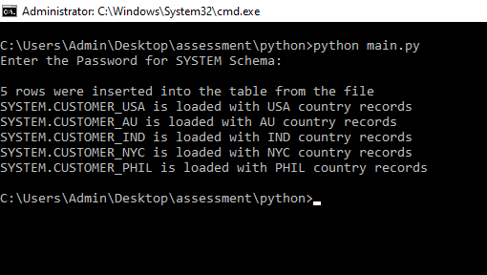

Figure : Python Script execution results

**RESULT:**

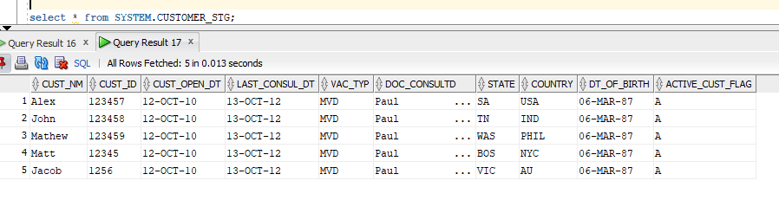

Figure : Staging table load

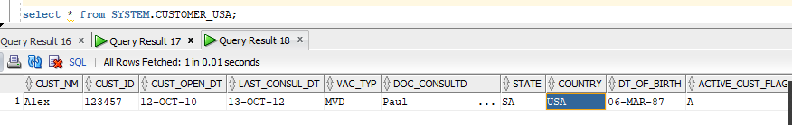

Figure : USA Table load

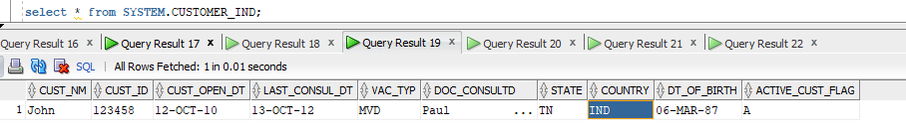

Figure : INDIA Table load

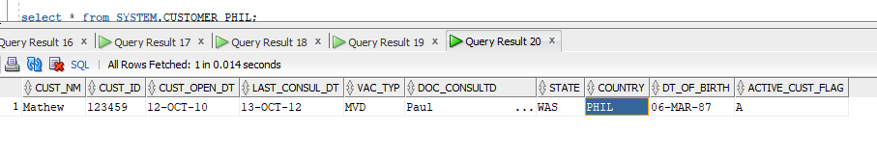

Figure : PHILLIPINES Table load

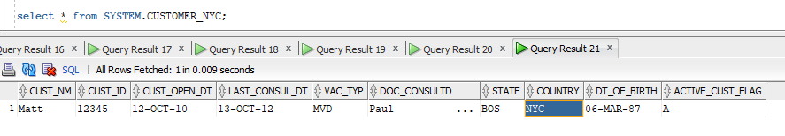

Figure : NYC Table load

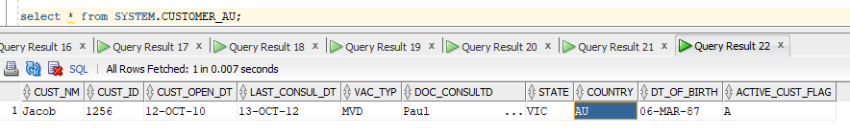

Figure : AUSTRALIA Table load